**Microsoft buys JavaScript developer platform npm; plans to integrate it with GitHub**

Microsoft is acquiring npm, a major JavaScript-developer platform officials announced on 16th march.GitHub has signed an agreement to acquire npm

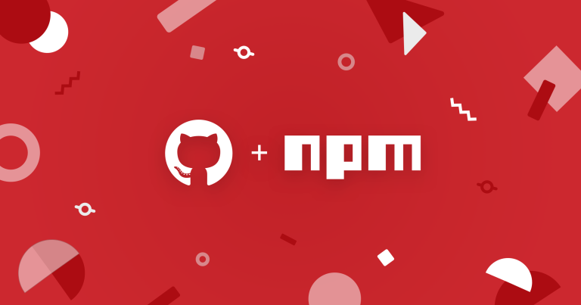

npm is a critical part of the JavaScript world. The work of the npm team over the last 10 years, and the contributions of hundreds of thousands of open source developers and maintainers, have made npm home to over 1.3 million packages with 75 billion downloads a month. Together, they’ve helped JavaScript become the largest developer ecosystem in the world.

For the millions of developers who use the public npm registry every day, npm will always be available and always be free. The focus after the deal closes will be to:

**Invest in the registry infrastructure and platform.** The JavaScript ecosystem is massive and growing quickly. It needs a rock-solid registry. We will make the investments necessary to ensure that npm is fast, reliable, and scalable.

**Improve the core experience**. Work to improve the everyday experience of developers and maintainers, and support the great work already started on the npm v7 CLI, which will remain free and open source. Some bigger features that we’re excited about are Workspaces and improvements to the publishing and multi-factor authentication experience.

**Engage with the community**.Actively engage with the JavaScript community to get your ideas and help us define the future of npm.